Project Development Phase
Model Performance Test – Script-Controlled ACL
Date: 03 October 2026
Team ID: SWTID-2026-8181
Project Name: Script-Controlled ACL – Restrict Record Access Based on Field Value
Maximum Marks: As per template
Model Performance Testing This project uses a Script-Controlled Access Control List (ACL) to compare the user's department with the record's department and return Allow or Deny. It is a rule-based security mechanism, not a machine-learning model.
S.No. | Parameter | Values | Screenshot / Evidence
1 | Model Summary | Rule-based Script-Controlled ACL. Compares the user's department with the record's department. | 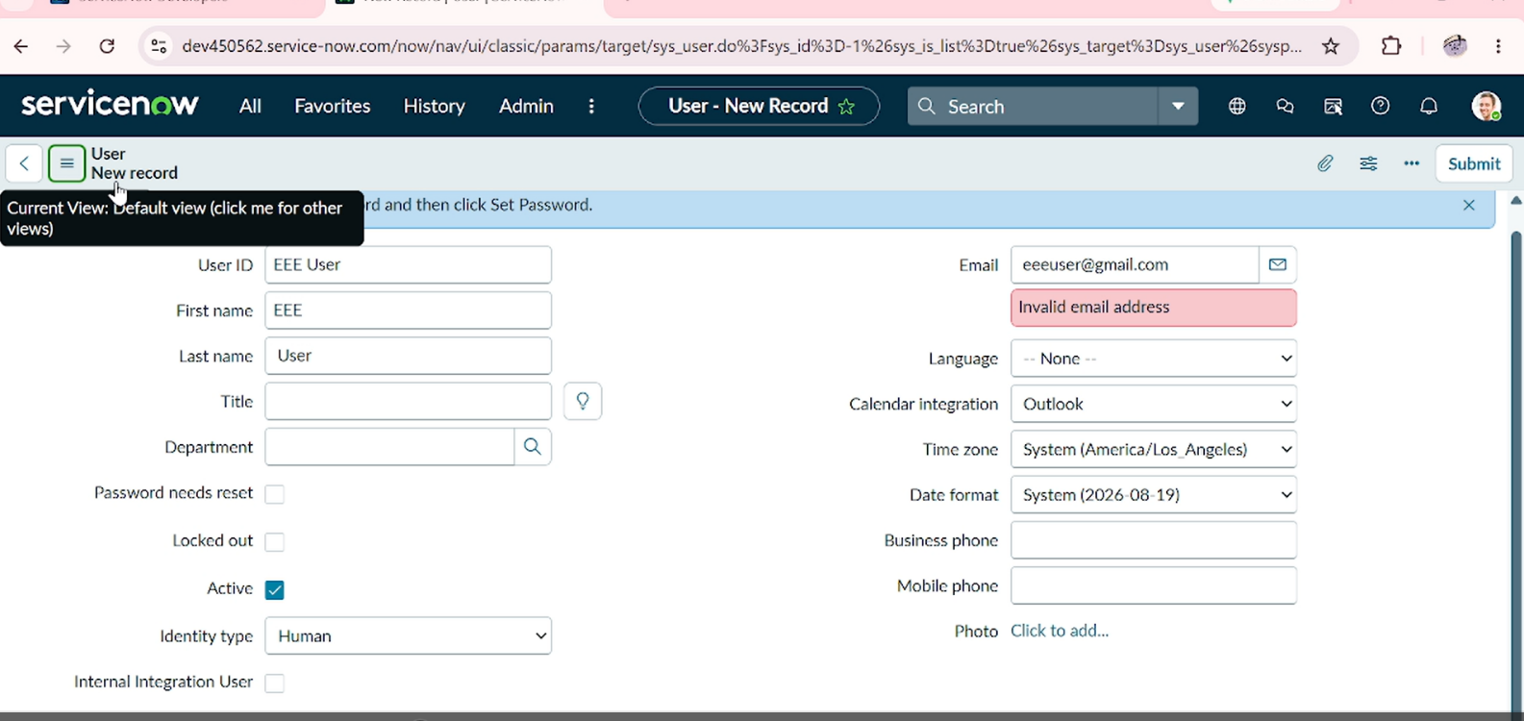
2 | Accuracy – Training Accuracy | Not Applicable – no machine-learning model or training dataset is used.
 | Validation Accuracy | Not Applicable – ACL behavior is validated through functional test cases. | 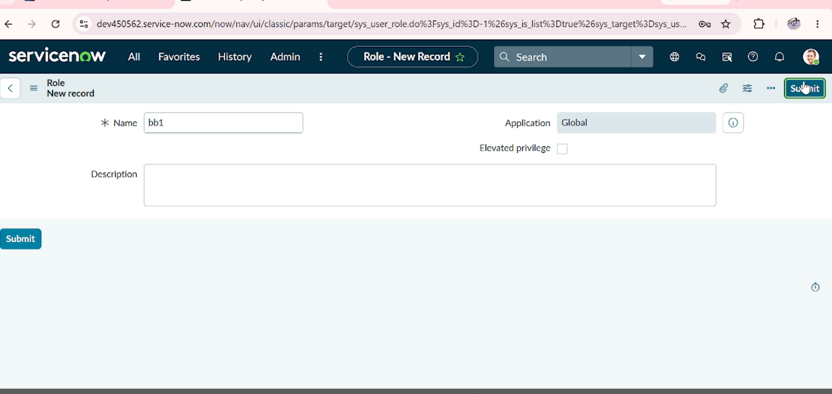
3 | Fine Tuning Result (if Done) | Not Applicable – no model fine-tuning is performed. | 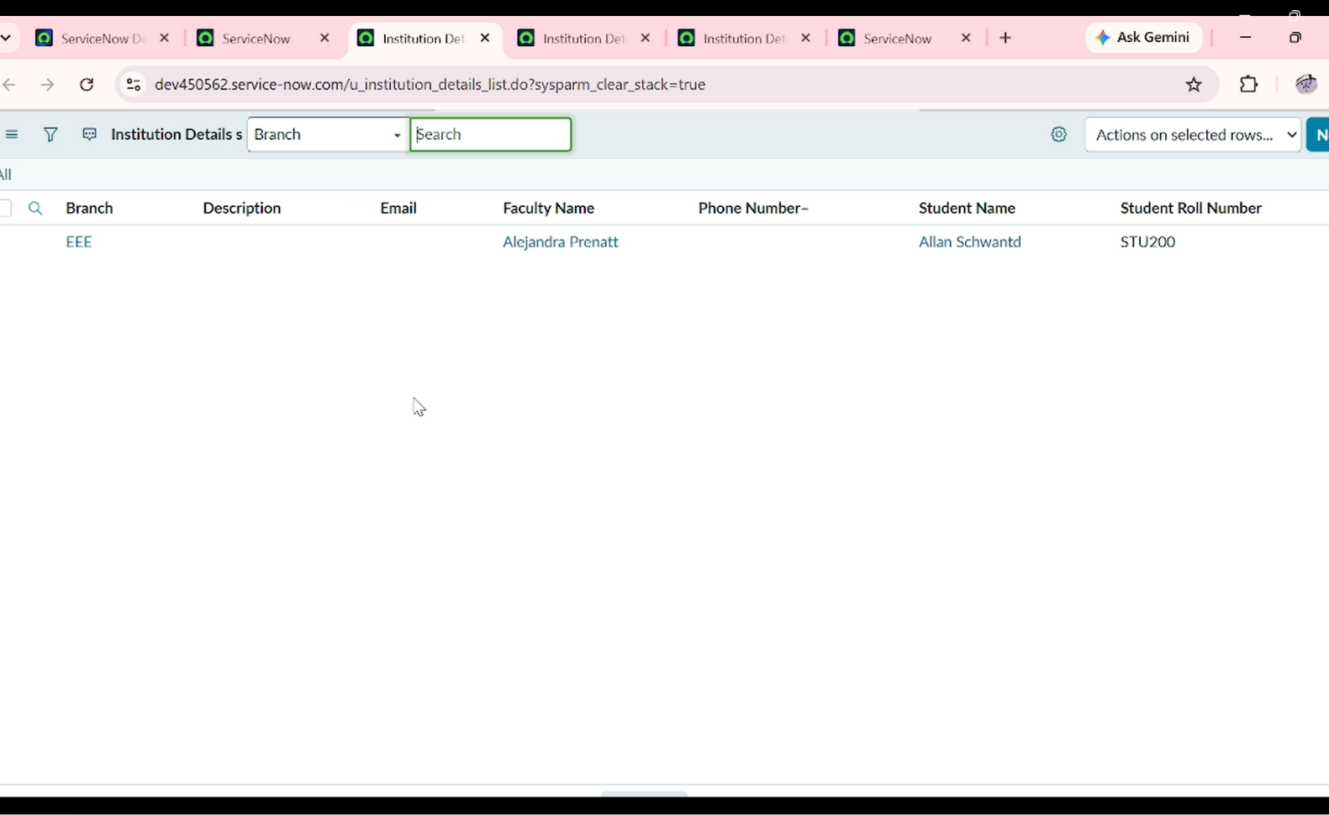
 | Validation Accuracy | Not Applicable – validation uses matching and non-matching department access tests.
ACL Functional Validation Summary
Test Condition | Expected Result
Matching department | Access Allowed
Non-matching department | Access Denied
Missing/invalid department | Access Denied
Administrator override, if configured | Access Allowed
Conclusion: The project does not require model accuracy or fine-tuning because it is an ACL-based rule engine. Performance is demonstrated through functional validation of authorized and unauthorized record access.

